Business Scenario
An e-commerce company named ABC sells products online across categories such as electronics, clothing, and home appliances. As the business has grown rapidly, its operational data is now distributed across tables such as Orders, Customers, Products, Payments, and Shipping. Because of this fragmented structure, leadership is facing difficulties in generating reliable reports, tracking customer purchase behaviour and analyzing product sales performance.
The client has approached the data team to design a well-structured data model that supports reporting, analytics, and future application development. The model should accurately represent the relationships among customers, products, orders, payments, and shipping, while reducing redundancy and improving data quality.
Based on the Joint Requirement Definition (JRD) sessions conducted with business and operational team, the primary business goal identified for the Business Requirements Document (BRD) is to build a data model that enables the organization to answer key business questions such as:
- Which products sell the most by category?
- Which customers are repeat buyers?
- Which orders are delayed in shipment?
After the BRD is finalized, Joint Application Design (JAD) meetings are conducted with analysts, data modelers, and developers to discuss and validate how the business requirements will be implemented in the solution. These meetings help clarify detailed functional needs such as report logic, business rules, data flow, entity usage, field definitions, and validations. The outcome of the JAD sessions is documented in the FRD (Functional Requirements Document), which captures the detailed functional specifications required for design, development, and testing.

Usage of Scrum Methodology
- Scrum is used as the project management approach to deliver the data modeling solution in iterative phases.
- The work is divided into sprints, where each sprint focuses on tasks such as requirement analysis, modeling, validation, or testing.
- A Product Backlog is prepared from the BRD and FRD, containing all business and functional requirements.
- In Sprint Planning, the team selects the backlog items to be completed in the next sprint.
- Daily Scrum meetings are conducted to track progress, discuss current work, and identify blockers.
- At the end of each sprint, a Sprint Review is held to present the completed work to stakeholders and collect feedback.
- A Sprint Retrospective is conducted to identify improvements for the next sprint.
- Overall, Scrum supports incremental delivery, continuous validation, and better collaboration throughout the project.
Data Modeling Life Cycle.
Conceptual and Logical Data Modeling representation using crow’s foot notation E-R diagram.
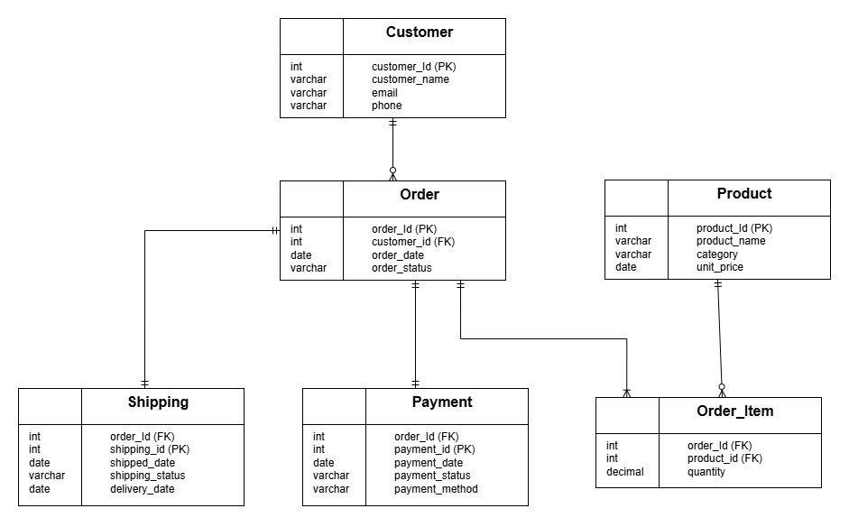
Normalization
The company initially stores order, customer, product, payment, and shipping details together in one combined structure for reporting or transaction capture. We will use this sample data and normalize it step by step.
Attaching and excel file with detailed Normalization.
Physical Data Modeling:
--create database scenario_ecommerce;

use scenario_ecommerce;

Create table Customer(
customer_id int primary key,
customer_name varchar(100) not null,
email varchar(100) not null check(email like '_%@_%._%'),
phone varchar(10) not null check(phone like '[1-9][0-9][0-9][0-9][0-9][0-9][0-9][0-9][0-9][0-9]')
);

Create table Orders(
Order_id int primary key,
Customer_id int foreign key references customer(customer_id),
Order_date date,
Status varchar(100) check(status in ('Pending', 'Confirmed', 'Shipped', 'Delivered', 'Cancelled'))
);

Create table Product(
Product_id int primary key,
Product_name varchar(100) not null,
category varchar(100) not null,
unit_price decimal(10,2) check(unit_price >=0)
);

Create table Shipping(
shipping_id int primary key,
order_id int foreign key references orders(order_id),
shipped_date date,
shipping_status varchar(100) check(shipping_status in ('Processing', 'Shipped', 'In Transit', 'Delivered', 'Delayed')),
delivery_date date
);

Create table Order_item(
product_id int foreign key references product(product_id),
order_id int foreign key references orders(order_id),
quantity int not null check(quantity > 0)

constraint pk_prod_order
primary key (order_id, product_id)
);

create table Payment (
payment_id int primary key,
order_id int not null unique,
payment_date date not null,
payment_status varchar(50) not null check (payment_status in ('Pending', 'Completed', 'Failed', 'Refunded')),
payment_method VARCHAR(50) not null check (payment_method in ('Credit Card', 'Debit Card', 'UPI', 'Net Banking', 'Cash')),
constraint fk_payment_order foreign key (order_id) references Orders(order_id)

Situation
The client wants to identify customers who place repeat orders and monitor product performance by analyzing total sales and quantities sold. This helps the business understand which products contribute the most to overall revenue and which customers demonstrate strong repeat-purchase behavior. Since customer retention and repeat buying are key indicators of business performance, the raw transactional tables do not present this information in a clear or summarized format. Therefore, a structured solution is needed to transform the transactional data into meaningful business insights.
Task
The task was to create database objects that provide a simple, reusable, and summarized view of key business information. One object was designed to present repeat customer details without requiring users to write complex joins and aggregations each time, while another was created to deliver a reusable product-level sales summary for reporting and analysis. This would make business insights easier to access, improve consistency in reporting, and reduce query complexity for end users.
Action
View for repeat customers

Create view vw_RepeatCustomers with encryption
As
Select
c.customer_id, c.customer_name,
count(o.order_id) as total_orders_count
From customer c
Inner join
Order o on c.customer_id= o.customer_id
Group by c.customer_id, c. customer_name
Having count(o. order_id) >1

View for product sales summary

Create view vw_ProductSalesSummary
as
select
p.product_id,
p.product_name,
p.category,
sum(oi.quantity) as total_units_sold,
sum(oi.quantity * p.unit_price) as total_sales
from Product p
inner join Order_Item oi
on p.product_id = oi.product_id
group by
p.product_id,
p.product_name,
p.category
Result / Impact
The views simplified reporting and made the data more accessible for analysts and business users. Instead of writing complex SQL queries with repeated joins and aggregations, users could directly query the views to identify repeat customers and evaluate product-level sales performance. This improved efficiency, encouraged code reusability, and provided a consistent way to analyze customer purchasing behavior.
In addition, the product sales summary view enabled faster reporting on total sales and quantities sold, making it easier to identify top-performing products and revenue contributors. This supported better managerial decision-making in areas such as inventory planning, sales strategy, and overall business performance analysis.

--------------------------------------------------------------------------------------------------------------

Situation
The client needed quick access to key order-related metrics such as the total amount of an order and the number of orders placed by a customer. These values were not directly available in a summarized form and required repeated joins and aggregations on transactional tables, making reporting and analysis more complex.

Task
The task was to create reusable database functions that could return these metrics in a simple and consistent way. The goal was to reduce query complexity, avoid repeating business logic, and make order and customer-level insights easier to use in reports, validations, and other SQL objects.

Action
Scalar UDF: total amount for one order
Create function udf_GetOrderTotal(@order_id int)
returns decimal(10,2)
as
begin
declare @total decimal(10,2)
select @total = sum(oi.quantity * p.unit_price)
from Order_Item oi
inner join Product p
on oi.product_id = p.product_id
where oi.order_id = @order_id
return isnull(@total, 0)
end
Scalar UDF: customer order count
create function udf_GetCustomerOrderCount(@customer_id int)
returns int
as
begin
declare @order_count int
select @order_count = count(*)
from [Order]
where customer_id = @customer_id
return isnull(@order_count, 0)
end
Result / Impact
The functions improved usability and reduced duplication of SQL logic. Users could directly retrieve important metrics without writing complex aggregation queries each time, which improved consistency, simplified reporting, and supported better analysis of customer activity and order value.

Situation
The client needed a reliable way to place customer orders while ensuring that business rules were enforced correctly. Since order placement involves validations such as checking customer existence, product availability, stock levels, and order amount calculations, handling this logic manually through separate queries could lead to errors and inconsistent data.

Task
The task was to create a stored procedure that could handle order placement in a controlled and reusable way. The goal was to validate the input data, perform the required calculations, and insert order records only when all business conditions were satisfied.

Action

A stored procedure was developed to accept order details as input, validate whether the customer and product existed, check whether sufficient stock was available, calculate the total order amount based on quantity and unit price, and then insert the order into the relevant tables. The procedure also included conditional logic to prevent invalid transactions and ensure data integrity.

create GO
create OR alter procedure dbo.sp_PlaceCustomerOrder
(
@order_id int,
@customer_id int,
@order_date date = NULL,
@order_items_json nvarchar(MAX),
-- example:
-- [{"product_id":1,"quantity":2},{"product_id":3,"quantity":1}]

@payment_id int,
@payment_method varchar(50),
@payment_status varchar(50) = 'Completed',

@shipping_id int,
@shipping_status varchar(50) = 'Processing',
@delivery_date date = NULL,

@order_status varchar(50) = 'Confirmed'
)
as
begin
SET NOCOUNT ON;
SET XACT_ABORT ON;

begin try
begin transaction;

declare @final_order_date date = isnull(@order_date, cast(getdate() AS DATE));
declare @total_amount decimal(18,2);

------------------------------------------------------------
-- validate customer
------------------------------------------------------------
if not exists
(
select 1
from Customer
where customer_id = @customer_id
)
begin
throw 50001, 'Customer does not exist.', 1;
end;

------------------------------------------------------------
-- validate duplicate keys
------------------------------------------------------------
if exists
(
select 1
from Orders
where order_id = @order_id
)
begin
throw 50002, 'Order ID already exists.', 1;
end

if exists (
select 1
from Payment
where payment_id = @payment_id
)
begin
throw 50003, 'Payment ID already exists.', 1;
end;

if exists
(
select 1
from Shipping
where shipping_id = @shipping_id
)
begin
throw 50004, 'Shipping ID already exists.', 1;
end;

------------------------------------------------------------
-- load JSON items
------------------------------------------------------------
if object_id('tempdb..#OrderItems') IS NOT NULL
DROP TABLE #OrderItems;

create table #OrderItems
(
product_id int not null,
quantity int not null
);

insert into #OrderItems (product_id, quantity)
select
product_id,
quantity
from openjson(@order_items_json)
with
(
product_id int '$.product_id',
quantity int '$.quantity'
);

if not exists(select 1 from #OrderItems)
begin
throw 50009, 'No order items were provided.', 1;
end;

if exists
(
select 1 from #OrderItems
where product_id is null
or quantity is null
or quantity <= 0
)
begin
throw 50010, 'Each order item must have a valid product_id and quantity > 0.', 1;
end;
------------------------------------------------------------
-- validate products
------------------------------------------------------------
if exists
(
select 1
from #OrderItems oi
left join Product p
on oi.product_id = p.product_id
where p.product_id is null
)
begin
throw 50011, 'One or more products do not exist.', 1;
end;

------------------------------------------------------------
-- calculate total order amount
------------------------------------------------------------
select
@total_amount = sum(cast(oi.quantity * p.unit_price as decimal(18,2)))
from #OrderItems oi
inner join Product p
on oi.product_id = p.product_id;

if @total_amount is null or @total_amount <= 0
begin
throw 50012, 'Total order amount must be greater than 0.', 1;
end;
------------------------------------------------------------
-- date consistency checks
------------------------------------------------------------
if @shipping_status = 'Delivered' and @delivery_date is null
begin
throw 50013, 'Delivery date is required when shipping status is Delivered.', 1;
end;

if @delivery_date is not null and @delivery_date < @final_order_date
begin
THROW 50014, 'Delivery date cannot be earlier than order date.', 1;
end;

------------------------------------------------------------
-- insert into Orders
------------------------------------------------------------
insert into Orders
(
order_id,
customer_id,
order_date,
status
)
values
(
@order_id,
@customer_id,
@final_order_date,
@order_status
);

------------------------------------------------------------
-- insert into Order_Item
------------------------------------------------------------

insert into Order_Item
(
order_id,
product_id,
quantity
)
select
@order_id,
oi.product_id,
oi.quantity
from #OrderItems oi;

------------------------------------------------------------
-- insert into Payment
------------------------------------------------------------
insert into Payment
(
payment_id,
order_id,
payment_date,
payment_status,
payment_method
)
values
(
@payment_id,
@order_id,
@final_order_date,
@payment_status,
@payment_method
);

------------------------------------------------------------
-- insert into Shipping
------------------------------------------------------------
insert into Shipping
(
shipping_id,
order_id,
shipped_date,
shipping_status,
delivery_date
)
values
(
@shipping_id,
@order_id,
case
when @shipping_status in ('Shipped', 'In Transit', 'Delivered')
then @final_order_date
else null
end,
@shipping_status,
@delivery_date
);

------------------------------------------------------------
-- return summary
------------------------------------------------------------
select
@order_id as order_id,
@customer_id as customer_id,
@final_order_date as order_date,
@total_amount as total_amount,
@payment_method as payment_method,
@payment_status as payment_status,
@shipping_status as shipping_status,
@order_status as order_status,
'Order placed successfully' AS message;

commit transaction;

end try

begin catch
IF @@trancount > 0
rollback transaction;

throw;
end catch
end;
GO

Procedure to place an order with validations and calculations
--- query writing in progress
Result / Impact
The procedure streamlined the order placement process and reduced the risk of incorrect or incomplete transactions. It improved consistency by centralizing validation and calculation logic in one reusable object, made the application workflow more reliable, and supported better control over inventory and order processing.

Situation
The client’s e-commerce database stores transactional data across Customer, Order, Product, Shipping, Payment, and Order_item tables. Since these tables are frequently used for joins, filtering, order tracking, and product-level reporting, query performance could degrade as data volume grows.
Task
The task was to design an indexing strategy that supports fast primary key lookups, efficient joins on foreign keys, quicker filtering on status/date columns, and better reporting performance for product and order analysis.
Action

create nonclustered index ix_orders_customerid
on Orders(customer_id);

create nonclustered index ix_orders_status
on Orders(status);

create nonclustered index ix_orders_orderdate
on Orders(order_date);

create nonclustered index ix_shipping_orderid
on Shipping(order_id);

create nonclustered index ix_shipping_status
on Shipping(shipping_status);

create nonclustered index ix_product_category
on Product(category);

create nonclustered index ix_orderitem_productid
on Order_Item(product_id);

create nonclustered index ix_orders_customer_covering
on Orders(customer_id)
include(order_date, status);

create nonclustered index ix_shipping_order_covering
on Shipping(order_id)
include(shipped_date, shipping_status, delivery_date);

Result / Impact
This indexing strategy improved overall database efficiency by speeding up joins, filtering, and reporting queries. It reduced unnecessary table scans, lowered I/O and CPU cost, and provided better performance for both transactional operations and business analysis.

